Objectives

- Define Props
- Explain Default Props
- Identify the differences between State and Props
- Explain reactDOM.render()

In this hands-on lab, you will learn how to:
- Use Props
- Apply reactDOM.render()

Prerequisites

The following is required to complete this hands-on lab:
- Node.js
- NPM
- Visual Studio Code

Notes

Estimated time to complete this lab: 60 minutes.
Create a React Application named “shoppingapp” with a class component named “OnlineShopping” and “Cart”.
- In Cart class, create 2 properties as mentioned below:
- Itemname
- Price
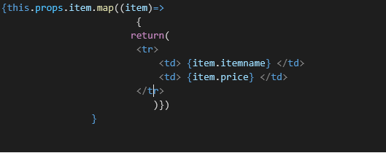
- In OnlineShopping class, create an array of Cart and initialize 5 items.

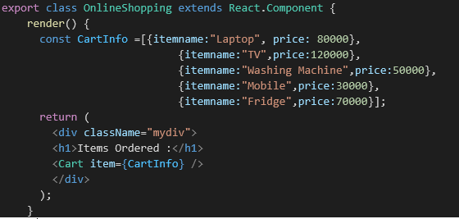

- Loop through these items and display the data as shown below:
